Commits:

(1)

I accidentally copied and pasted my two QLineEdits in "Add a Course" and forgot to remove them. So basically, there's a QLineEdit behind a QLineEdit. The reason why, my two QLineEdits are always empty even though I typed some data on it. But do not fret, if I'm going to delete my two QLineEdits (which is an easy process), my "Add a Course" will be functional again, as easily as that.

The problem above, consider it done. I uploaded again a new folder since I cannot directly edit the minor problem (UI) on VSCode especially for UI because I'm using a QTCreator. I deleted the two QLineEdits in the 'mainwindow.ui'. With that, the problem was solved.

(2)

I edited my two CSV files by filling in 100 students in my InfoStudents.csv and some additional courses in my InfoCourses.csv.

(3)

In my ‘addbutton.cpp’, I added a constraint if the user inputs a specific ID Number already existing.

So, I Replace This:

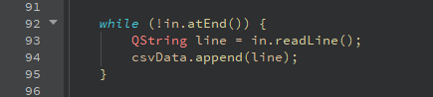

With This:

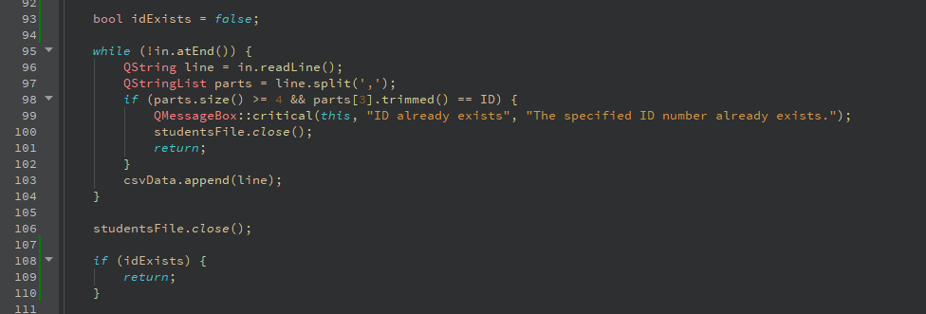

(4)

In my ‘mainwindow.cpp’, I noticed in my search function that it gets confusing when users have the same last name and first name. So, in my ‘SearchButton’ function, I added an ID Number to display it to the search area whenever a specific ID Number or Last Name is being searched.

So, I Replace This:

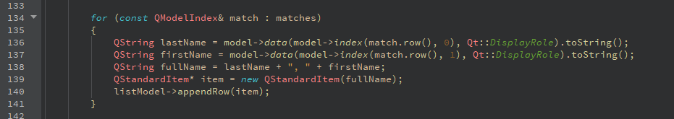

With This:

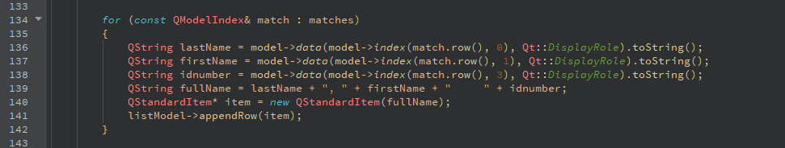

(5)

In my ‘mainwindow.cpp’, I added a constraint in my ‘SaveButton’ function whenever the user edits an ID Number that already exists.

So, I added this line of codes.

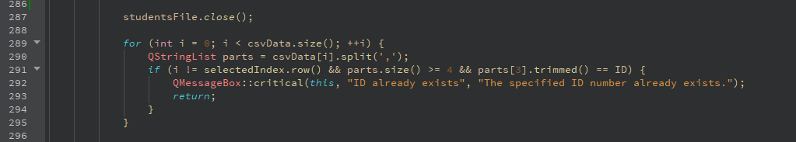

(6)

In my ‘mainwindow.cpp’, I also added a constraint in my ‘addCourseButton’ function whenever the user adds a specific course that already exists.

So, I added this line of codes.

